**Alarm System**

Niculescu Oana

**1. Introduction**

This project is an alarm system made on the Altera DE1 Development board using Verilog HDL and the Quartus II software. It uses an ultrasonic HC-SR04 sensor to detect the distance at which an object is placed from it. In the event that this object is less than 100 centimeters away, an alarm is triggered, which will play through the speakers connected to the Line Out of the DE1 board. There are only two ways the user can interact with the project: placing an object in front of the sensor to see the distance that is picked up and, thus, trigger the alarm, or resetting the system.

**2. Top Module**

The Top module is only used to create instances of the submodules that the project consists of.

**2.1. Inputs**

**CLK** – The board’s 50 MHz oscillator clock, will be used for clock dividers throughout the project

**RST** – The system reset mapped to one of the keys on the board (KEY0)

**Echo_Sig** – The signal the HC-SR04 sensor sends back to the FPGA, based on which we can measure the distance to the object placed in front of the sensor

**2.2. Outputs**

**XCLK** – The chip clock used by the Audio Decoder on the DE1 Board (Wolfson WM8731)

**BCLK** – The Bit-Stream clock used by the Audio Decoder

**DACLRCK** – The alignment clock used by the Audio Decoder for the left and right channels

**Trigger_Sig** – The trigger signal sent to the HC-SR04 sensor to begin measurement

**Distance** – The distance the object is placed from the sensor, to be shown on the 7-segment digit display

**Sound_Data** – The beep sent to the Audio Codec to be outputted through Line Out

**2.3. Bidirectional**

**I2C_Data** – The data signal that selects the Audio Codec as the current chip the FPGA interacts with and provides the write operation, while also receiving an acknowledge bit from the codec

**I2C_Clock** – The clock signal sent to the Audio Codec for control

**2.4. Internal wires**

**T_CLK** – The trigger clock used in generating the trigger signal sent to the HC-SR04 sensor

**Distance_Raw** – The distance the object is placed from the sensor, to be transformed into the corresponding signals for the 7-segment displays

**3. Block Diagram**

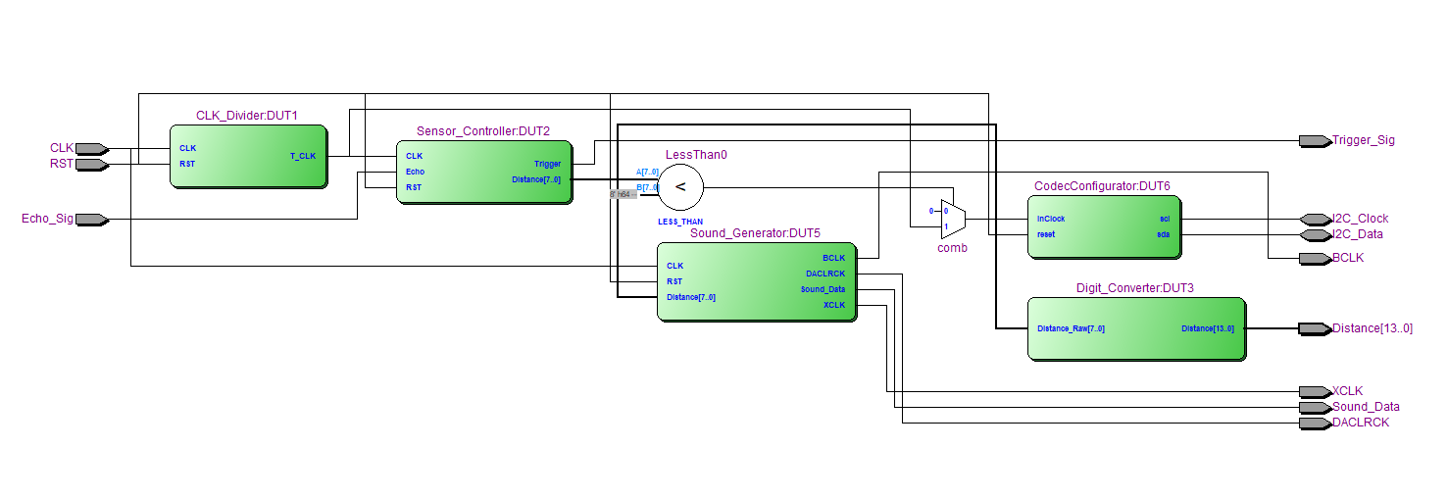

**4. Submodules**

**4.1. Clock Divider**

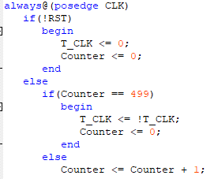The **CLK_Divider** module generates the trigger clock, which is 100 KHz. To do this, a counter is used to invert a signal every 500 cycles of the main clock, **CLK**.

**4.2. Sensor Controller**

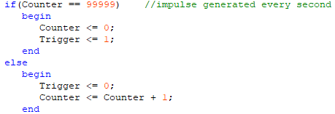The **Sensor_Controller** module uses the previously generated trigger clock to send a trigger signal to the sensor. Since the sensor only needs one 10 µS impulse to begin measuring, a single cycle of the trigger clock is enough. For the purpose of this project, this impulse is generated once every second (the sensor only measures once every second).

Furthermore, a counter is used to measure the number of cycles between when the trigger signal was sent and when the echo was received. The following formula is used from the HC-SR04 datasheet to calculate the distance from the object:

Since the counter only goes up every cycle of the trigger clock, each cycle counted is 10 µS.

**4.3. Digit Converter**

The **Digit_Converter** submodule transforms the distance calculated by the sensor controller into 7-segment display signals. Since our target range varies between 0-99 centimeters, two digits are used to display the value. First, the two digits are extracted:

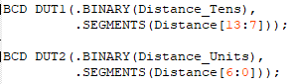Then, the digits are transformed into their respective signals using two instances of the **BCD** module.

**4.4. Sound Generator**

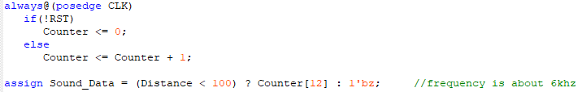The **Sound_Generator** module uses the main clock to send the necessary synchronization clocks and the sound data to the Audio Codec. It is essentially a clock divider module, but using a different method than the one used by the **CLK_Divider**. A 16-bit counter is used so that a sound signal of ~6KHz is generated.

The synchronization clocks are different fractions of the main clock, needed by the codec to output the sound to the headphones.

**4.5. Codec Configurator**

The **CodecConfigurator** module is a third-party module [1] that acts as an interface for the I2C protocol used to control the Audio Codec. It is an automata that cycles through the stages needed to form a connection between the FPGA and the Wolfson Codec. The start and stop conditions are controlled, the device is selected, the specific operation data is sent (e.g. activation, powering down, left line in, right line in) and the final I2C clock is generated. These are connected to the bidirectional I2C buses.

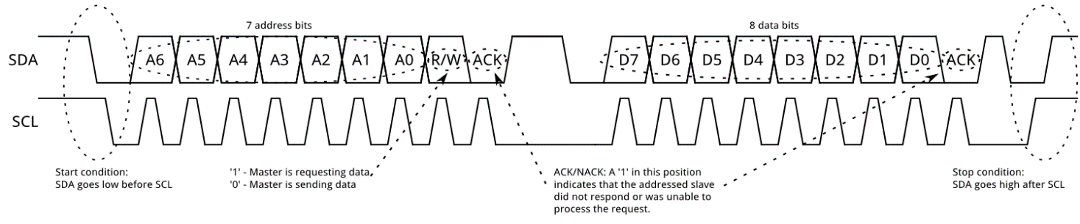The following figure [2] shows the stages the I2C automata goes through to ensure a connection to the Wolfson chip:

In this situation, the master will always be sending data, since the microphone Line In is not used.

**5. Observations and difficulties**

Previous difficulties in the realisation of this project were the correct testing of the echo signal every cycle of the trigger clock within the **Sensor_Controller** module. As it stands, the measurement is not precisely accurate, but for the purpose of this project, it is sufficient to creating an alarm system.

A second problem was correctly generating the sound signal and the clocks used by the codec for synchronization, for which Albiach, J.’s thesis [3] on interfacing provided a solution. Thus, I was able to use a basic clock diving circuit to now correctly output a sound though the Line Out port to the headphones.

At last, the current state of the project does not allow changing the volume of the outputted sound, needing to alter the structure of the I2C automata to permit this operation to be done using the buttons on the DE1 board.

**6. References**

[1] - https://github.com/Goshik92/FFTVisualizer

[2] - https://learn.sparkfun.com/tutorials/i2c

[3] - Albiach, J. I. M., 2006. **Interfacing a processor core in FPGA to an audio system**. Linköping Institute of Technology.